Proposal to Provide Regulatory Compliance Advisory and Managed Services

Prepared for:

February 2, 2026

FS Vector
1307 New York Ave NW
Washington, DC 20005
fsvector.com
(202) 864-6547

Table of Contents
Engagement Background 2
Advisory By The Numbers 3
Select Advisory Clients 4
Engagement Scope 4
Partnership Engagement 4
Compliance Gap Analysis and Program Development 4
Managed Services 6
Ongoing Advisory Services 7
Headmaster™ Compliance Training 7
Optional Services: Staffing and Recruiting 8
Budget and Timeline 9
FS Vector Leadership Team 10
FS Vector Advisory Team 12

Engagement Background
Bakkt Holdings, Inc. (“Bakkt”) is a leading financial infrastructure company that provides solutions enabling institutional and consumer participation in the digital asset economy. Originally founded by Intercontinental Exchange, Bakkt has evolved from its roots in cryptocurrency custody and trading to become a unified global financial infrastructure platform spanning Bitcoin trading, stablecoin payments, and AI-driven finance.
Bakkt is seeking to launch an unsecured consumer credit card product in partnership with a bank partner. As part of this strategic initiative, Bakkt requires assistance with program management, compliance program design, operational workflows, and implementation support to ensure its controls are efficient, scalable, and aligned with regulatory requirements and bank partner expectations for consumer credit products.
To support this evolution, Bakkt is seeking comprehensive advisory services including a review of existing compliance policies and procedures, a gap analysis to identify remediation needs, compliance program development, and ongoing managed services to support the credit card program launch and operations.
FS Vector’s Advisory Team has unparalleled experience helping fintech companies design product structures, secure partnerships, and build operational compliance programs. Throughout the engagement, FS Vector will work closely with Bakkt to efficiently manage engagement progress and to ultimately sustain a product that is both innovative and regulatory compliant.
About FS Vector
FS Vector is the go-to advisory firm with a range of service offerings for innovative companies in the financial services sector. As a partner to our clients, we’ve developed an engagement model that allows us to collaborate daily on matters that impact their business across a range of areas.
FS Vector understands the needs of early, growth-stage, and large innovative organizations. Our team’s track record and skillset drive smart solutions and a practical approach to addressing novel issues and achieving positive outcomes for our clients.
Our services are organized as follows:
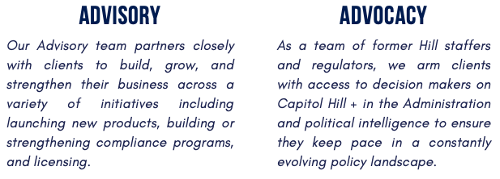
Relevant Experience

Advisory By The Numbers
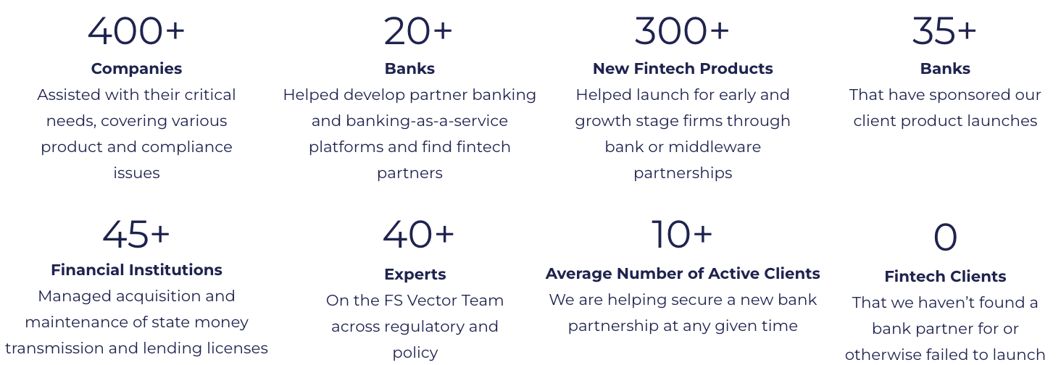

Select Advisory Clients
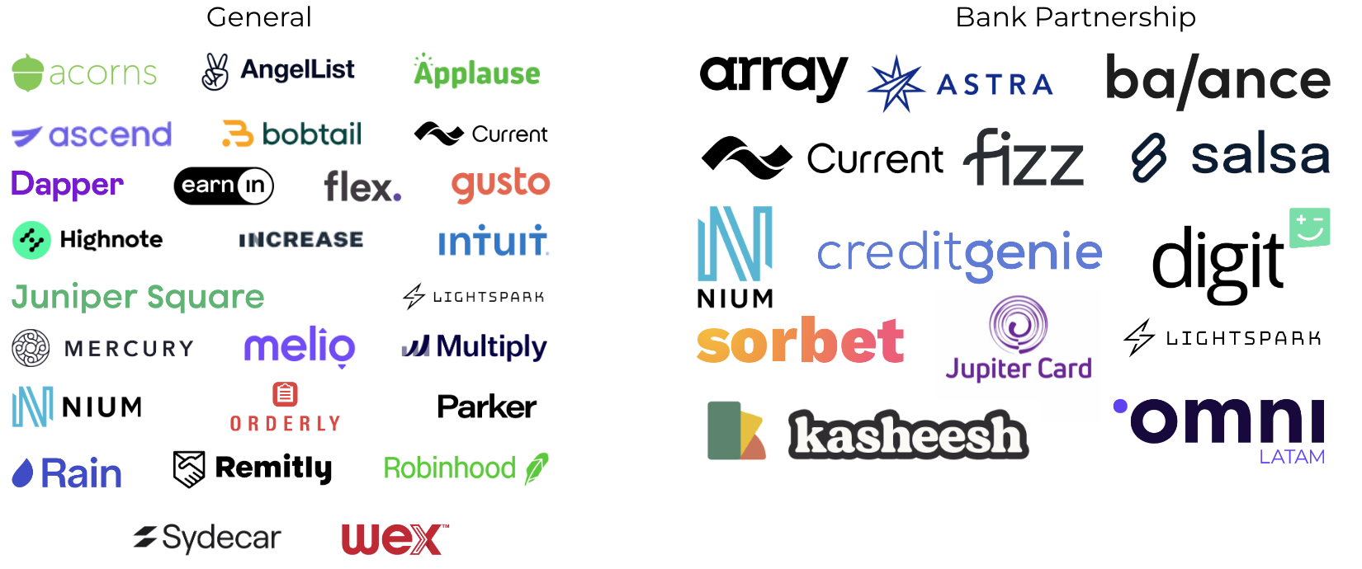

Engagement Scope

Partnership Engagement
FS Vector will assist Bakkt to efficiently navigate bank and vendor partnerships for the consumer credit card program. We will:
- Assist with navigating and evaluating different partner setups for the credit card program, including introductions, term sheet modeling, and negotiation support, including sharing our experiences and finding peer references for each partner.
- Provide project management support to ensure an efficient due diligence and onboarding process.
- Assist with fulfilling counterparty requests and responding to questions raised by the bank partner and other counterparties during the process.

Compliance Gap Analysis and Program Development
FS Vector will conduct a comprehensive review of Bakkt's existing compliance policies and procedures and perform a gap analysis to identify areas requiring remediation to support the launch of the unsecured consumer credit card product. We will:
- Review Bakkt's current compliance policies, procedures, and controls to assess their applicability and sufficiency for a consumer credit card program.
- Conduct a gap analysis comparing Bakkt's existing compliance framework against regulatory requirements and bank partner expectations for unsecured consumer credit products.
- Develop a remediation roadmap to address identified gaps, prioritized by risk and regulatory criticality.
- Assist with building or enhancing compliant processes, disclosures, and other related items into the credit card product.
FS Vector will also provide services to further develop the compliance program and other information or artifacts needed to satisfy regulatory and partner requirements. This service may include the following services and deliverables:
- Create a regulatory applicability matrix that identifies the applicable US regulations for consumer credit products and maps them to existing or new compliance functions.
- Revise and/or draft internal compliance and risk management policies, procedures, and workflows.
- Review and provide guidance on internal controls, including the selection of regulatory technology solutions to assist with automating compliance functions.
- Assist with fulfilling partner due diligence and responding to issues or concerns raised by the bank during the process.
FS Vector anticipates that the assistance will include developing compliance programs and related components such as the following, as applicable:
Financial Crimes | Complaint Management | Enterprise Compliance
- Anti-money Laundering Program  - Sanctions Program  - Fraud and Identity Theft Program | - Complaint Management  - Dispute Management  - Returns Process | - Change Management  - Record Retention  - Issue Management  - Audit Policy/Plan
Marketing and Advertising | General Risk | Consumer Credit Compliance
- Advertising/Marketing Policy  - Marketing Materials Review Process and Guidelines  - UDAAP Policy | - Privacy Program  - Information Security  - Vendor Risk Management  - Business Continuity  - Model Risk Management | - Truth in Lending Act (TILA)  - Fair Credit Reporting Act (FCRA)  - Equal Credit Opportunity Act (ECOA)  - Periodic Statements  - E-Sign Act

Managed Services
Following the initial advisory and program development phase, FS Vector will manage compliance and risk management operations related to the consumer credit card program on an ongoing basis. As part of this, FS Vector will provide and perform the following:
- Collections support and management
- Cardholder support operations
- Disputes management and resolution
- Consumer complaints handling and tracking
- KYC and sanctions screening
- Compliance monitoring and testing
- AML/fraud transaction monitoring
- Unusual activity reporting
- Reg. E and Reg. Z disputes
- UDAAP marketing reviews
- Fraud investigations and dispute response support
- Management of risk programs, such as TPRM, BCP, etc.
FS Vector will provide a Compliance Officer, Compliance Manager, and Compliance Analysts to manage these controls and coordinate directly with the partner bank and Bakkt.
FS Vector will work with Bakkt to leverage existing regtech solutions across the Bakkt compliance, risk, and operations programs. If desired, FS Vector can provide third party regtech platforms to enable the services, and pass the cost of those through to Bakkt.
FS Vector will engage with the bank on navigating onboarding due diligence, ongoing oversight, testing requirements, and other compliance matters related to the consumer credit card product.
Based on the scope of this engagement, we anticipate that the managed services component will primarily require Analyst-level work with Manager and limited Compliance Officer involvement. Hourly estimates will depend on volume. Below is our standard rate schedule for managed services:
Seniority Level | Hourly Rate
Compliance Analyst | $90 - $110
Compliance Manager | $125 - $150
Compliance Officer | $180 - $275
Head of Compliance | $275 - $400

FS Vector is happy to discuss volume-based discounts on hourly rates as the program scales.

Ongoing Advisory Services
FS Vector will serve as an ongoing advisor to Bakkt to promote product development, launch, and growth by providing access to our full team, range of advisory services, and other capabilities. This includes advising on matters related to regulation, partnerships, vendor selection, regulatory compliance, product and geographic expansion, and other relevant challenges that Bakkt may experience as the business continues to grow and scale.
At the outset, FS Vector will assist Bakkt with the following:
- Assist with complying with partner’s ongoing reporting and compliance requirements, including audits and reviews.
- Assist with managing ongoing compliance tasks, including escalated alerts, disputes, and other matters.
- Assist with other items needed to fully operationalize a strong and repeatable compliance program, including desktop procedures and process workflows.
- Support and lead the ongoing maturation of the compliance management system, in terms of documentation, sophistication, and automation.
- Advise on the development of new products, services, and features.

Headmaster™ Compliance Training

Headmaster is FS Vector’s compliance training and learning management software built specifically for fintech companies. The content and platform are designed to meet bank partner requirements and has been built to go beyond checking a box and building a culture of compliance.
The platform includes the following components:
- Online training courses covering areas such as: AML, Complaint Management, Deceptive Practices, Business Continuity, Privacy, Fair Lending, and much more.
- Periodic Headmaster Briefings containing regulatory updates, best practice guides, and other materials.
- Assessments including quiz questions and other tests.
- Compliance tracking and reporting of employee completion data.
We include the use of Headmaster with our advisory services for the duration of the engagement.

Optional Services: Staffing and Recruiting
From C-suite to operations, we find highly qualified candidates that can seamlessly integrate into your team on a full-time, interim, or fractional basis. Working closely with your FS Vector advisors, our talent specialists will craft tailored job descriptions, set qualifications, define compensation targets, and source and vet recruits prior to passing them to your leadership for interviews. Examples of roles that we recruit for include:
- Chief Compliance Officer or Head of Compliance
- Chief Risk or Credit Officer
- General Counsel or Regulatory Counsel
- Bank Secrecy Act Officers
- Know Your Customer and Fraud Analysts
- AML Alert Analysts and Investigators
- Compliance Analysts
- Software Engineers
- Product Managers

Budget and Timeline
Our goal is to be a trusted advisor, develop long-term partnerships, and ensure our clients meet their goals. In this regard, we strive to provide flexible engagements that align with our clients’ needs and timelines, while also providing certainty for budgeting purposes. We propose the following services and fee structure.
Month | 1 - 2 | 3 - 4 | 5+
Advisory Services | Regulatory Applicability Analysis  Gap Analysis & Remediation Roadmap  Compliance Policy & Procedure Review  Partner Engagement | User Onboarding and Product Compliance  Target Operating and Staffing Model  Operationalize Compliance Controls  Compliance Training  Product Launch | Ongoing Advisory Services
Monthly Advisory Fee | $22,500 |  | Per Bakkt’s needs

Throughout the engagement, FS Vector will work closely with Bakkt to discuss project goals and timelines. FS Vector will establish a Slack channel to collaborate with Bakkt daily and meet with Bakkt staff throughout the week over video conferencing calls.

FS Vector Leadership Team
Senior Leadership
John Beccia III
Co-Founder and Chair

John provides a wide range of regulatory and compliance solutions for financial services, fintech, and cryptocurrency firms. He was most recently General Counsel and Chief Compliance Officer of Circle Internet Financial, Inc., a global crypto finance company that is seeking to help change the global economy.
John previously served as Senior Vice President and Deputy General Counsel for Boston Private Financial Holdings, Inc., a publicly traded bank holding company. He was also Assistant General Counsel for Investors Bank & Trust Company and Chief Regulatory Counsel and Research Director for The Financial Services Roundtable.
John earned a J.D. from Roger Williams University School of Law.
Emily Goodman, Partner

Emily leads FS Vector’s Licensing practice, a core offering with our Advisory team. She serves as a strategic advisor to licensing clients, with expertise in license and charter strategy, acquisition, maintenance, product development, compliance, operations, examinations, assessments / audits, marketing, regulatory relations, M&A and investments, changes of control, partnerships and agency structures, and fraud/risk. The types of state licenses and charters that Emily supports include: state money transmission, B2B finance, lending, brokering, collections and digital assets.
Prior to joining FS Vector, Emily was Chief Legal Officer of HQ Digital, an early-stage digital multi-family office serving digital asset entrepreneurs and investors, as well as Lead Product & Regulatory Counsel at Brex. Before that, Emily spent a decade at American Express, where she was Vice President & Senior Counsel supporting the Digital Labs business unit. She started her career in the Financial Institutions & Payments group at Schulte, Roth & Zabel.
Emily earned a J.D. from Fordham University School of Law.
Chris Sidler, Partner

Chris advises financial services firms and their partners, focusing on regulatory compliance, risk management, and product development. He has helped dozens of firms by constructing operating models for effective governance, assessing risks and controls, and designing processes that integrate emerging technologies and advanced analytics, with a particular expertise in anti-money laundering (AML) and economic sanctions.
Chris was most recently a managing director at Berkeley Research Group following over thirteen years at Promontory Financial Group in the United Kingdom and the United States, where he co-led the Americas financial crime compliance practice and helped to build and operate the firm’s regtech and managed service affiliates. Prior to consulting, he worked with the United Nations in Tanzania through the UN Association in Canada.
He holds a M.Sc. from The London School of Economics and Political Science.
Ashwin Vasan, Partner Advocacy Team

Ashwin was most recently Associate Director of Research, Monitoring and Regulations at the Consumer Financial Protection Bureau (CFPB). He oversaw a team that led the bulk of the CFPB’s policy development work (research, reports, and regulations) and served as an advisor to Director Rohit Chopra. In addition to his time at the CFPB, he was formerly at Capital One and McKinsey & Company.
In his role as Partner at FSV, Mr. Vasan advises FSV clients, which include fintechs, banks and other financial institutions, on a wide variety of business strategy and regulatory matters.
Ashwin earned a J.D. from Harvard Law School.
Select Senior Advisors
Raj Date

Raj is a co-founder of FS Vector and works with clients in financial services and financial technology. Raj serves as Director for a number of innovative firms in financial services: Prosper, the marketplace lender; Green Dot, the bank holding company; Circle, the digital asset firm; Grasshopper, a de novo bank; College Ave, a private student lender; and Megalith, a fintech-focused SPAC.
Raj is the Managing Partner of Fenway Summer, an advisory and investment firm. Previously, Raj was the first-ever Deputy Director of the U.S. Consumer Financial Protection Bureau (CFPB). Before his time in public policy, Raj was a Managing Director in the Financial Institutions Group at Deutsche Bank Securities, where he led the firm’s investment banking coverage for the largest U.S.-based banks and thrifts.
Raj earned a J.D. from Harvard Law School.

David Cotney

David advises FS Vector’s financial services clients on regulatory issues. David previously served as Commissioner of Banks for the Massachusetts Division of Banks where he was responsible for the supervision of nearly 200 state-chartered banks and credit unions.
David also served as the Chairman of the State Liaison Committee of the Federal Financial Institutions Examination Council (FFIEC), and as Chairman of the Board of Directors of the Conference of State Bank Supervisors (CSBS). He also serves as a member of the Board of Directors at Cross River.
David earned an MPA from Harvard Kennedy School and an MBA from Boston University.

FS Vector Advisory Team
Managing Principals
Dana Antenucci

Dana is an expert in regulatory compliance and project management, with a special focus on working within KYC, Anti-money Laundering (AML) compliance programs and Sanctions Control Programs (SCPs), including program audits, risk assessments, regulatory look-backs, investigations, legal writing, and SAR writing.
Prior to joining FS Vector, Dana worked within BDO USA’s Risk & Regulatory Advisory practice where she worked with a range of financial institutions, from fintechs to large depositories. She also worked in Wells Fargo’s Financial Investigations Group and at HSBC as an AML investigator.
She is a licensed attorney (New Jersey) with a J.D. from Northeastern University School of Law.
Princeton Graham

Princeton advises clients on a broad range of operational, risk management, and strategic initiatives. Princeton works with leading fintech companies and traditional financial services institutions on strategic planning, regulatory analysis, product development, licensing, partnerships and building and implementing risk and compliance infrastructures.
Prior to joining FS Vector, Princeton was a consultant at Treliant. Before Treliant, Princeton worked at Ffestiniog Company, a private family office, and QED investors, a global fintech venture capital firm where he provided strategic and operational support. Princeton also worked for U.S. Senator Tim Kaine, U.S. Senator Mark Warner, and Cornerstone Government Affairs.
Princeton holds an B.A. degree in Political Science, cum laude, from Virginia Tech.
Max Sherman

Max supports clients on a broad range of strategic and regulatory compliance initiatives. He specializes in building, implementing, and enhancing compliance functions for both early stage and large Fintech companies.
Max has significant experience designing and operationalizing compliance and risk management programs, with a focus on financial crimes and consumer compliance within a broad range of financial products and services, including payments, digital banking, and marketplace lending, among others.
Max was previously a Compliance Lead at Column National Association. Prior to Column, He was a Consultant at Treliant, the Export-Import Bank of the United States, and the U.S. Department of the Treasury.
Max holds a B.A. in International Relations from the School of International Service at American University in Washington, D.C.
Ethan Singleton

Ethan is an experienced financial services advisor who specializes in helping financial institutions and fintechs navigate the complexities of banking-as-a-service programs. At FS Vector, Ethan leverages his expertise to coordinate the launch of bank-fintech partnership programs, working closely with state and federally chartered banks, fintechs, technology providers and other ecosystem partners. He brings deep expertise in designing and implementing comprehensive compliance programs for fintech startups, neobanks, digital asset platforms, and other innovative financial services companies.
Prior to joining FS Vector, Ethan was a Manager in the Compliance & Regulatory Advisory practice at BDO USA, where he led AML/OFAC assessments and consultations on unique compliance issues related to fintech partnerships. He has driven innovative compliance efforts in client adoption of AI, RPA, and machine learning to enhance processes and mitigate risks. Earlier in his career, he was a member of the Financial Crimes Regulatory Compliance group at HSBC Bank USA.
Ethan received a B.A. in Political Science and an M.B.A from the University of Delaware, and a J. D., cum laude, from the Delaware Law School of Widener University.
Jasper Sneff Nanni

Jasper advises and supports clients with a range of strategy, compliance, and risk management matters. His work with FS Vector focuses on the development of governance and management structures for burgeoning financial firms.
Jasper has extensive experience supporting financial institutions in strategic efforts, such as investment portfolio optimization and bank profitability analyses; internal capital planning and regulatory stress testing exercises; and model risk management. Jasper has also assisted financial institutions with developing enterprise risk management and financial crimes compliance programs, and has conducted forensic reviews involving consumer protection and AML/sanctions compliance. Jasper was previously a member of the Financial Markets Advisory team at BlackRock.
Jasper received an A.B. degree in Sociology, cum laude, from Princeton University.
Trevor Tanifum

Trevor guides financial technology companies through regulatory, risk management, and strategic challenges. Trevor is passionate about the deliberate integration of compliance activities with business processes and products and strives to help clients gain efficiencies and value-add from their compliance departments.
Trevor was previously a principal at Promontory Financial Group where he counseled financial institutions through a range of strategic, programmatic, and esoteric undertakings. Trevor, a lawyer by training, previously clerked for former Commodity Futures Trading Commission (CFTC) Commissioner Sharon Y. Bowen where he helped launch the inaugural Market Risk Advisory Committee. Later, at the Financial Industry Regulatory Authority (FINRA), Trevor conducted investigations of potential securities law violations.
Trevor earned a J.D. from The George Washington University Law School.
Principals
Tom Gentle

Tom advises financial institutions and cryptocurrency companies on regulatory compliance, with a particular focus on anti-money laundering (AML) and financial crime risk management. With a strong background in assessing risks, developing controls, and implementing compliance strategies, Tom helps organizations navigate complex regulatory landscapes.
Tom was previously the Compliance Officer for Quadrata, a Web3 digital identity and Compliance-as-a-Service startup and the Head of AML Operations for an early-stage cryptocurrency exchange. He also served as the BSA/AML Compliance Quality Assurance Lead at Coinbase.
Tom holds a B.A. degree from Northeastern University and is a Certified Anti-Money Laundering Specialist (CAMS).
Claire Gong

Claire advises banks and fintech companies on a wide range of financial services matters, including regulatory compliance, risk management, business strategy, operations, and product development. Within these areas, she has focused her expertise principally in consumer compliance.
Prior to joining FS Vector, she served as a Principal at Promontory Financial Group and a Senior Manager at Treliant. In these roles, she worked with global and domestic financial institutions and fintechs, developing and executing compliance programs, product and market strategies, operational resilience, and regulatory remediations.
Claire holds a B.S. in Finance and a B.A. in English Literature from Beijing Foreign Studies University and an M.P.P. from Georgetown University.
Evey Guo

Evey advises clients on the development and launch of new products and the maturation of existing programs. She has extensive experience defining and executing strategies for pursuing national and state bank and trust charters among other licensing regimes. Her work involves technical financial analysis and the construction of enterprise risk management and compliance programs.
Prior to joining FS Vector, Evey was a Principal at Promontory Financial Group. She assisted bank and non-bank clients with U.S. chartering and licensing strategies and in executing end-to-end charter application processes. Evey also helped financial institutions and fintechs evaluate and enhance their risk management and compliance programs. She has been involved in several large-scale regulatory remediations.
Evey earned a master's degree in finance from the University of Maryland, College Park and a Bachelor of Finance from Nankai University.
Guy Huber

Guy helps clients launch products, build and improve compliance programs and navigate bank partnerships.
Prior to joining FS Vector, Guy was a Senior Managing Consultant at Promontory Financial Group. At Promontory, Guy advised a range of domestic and international financial institutions on regulatory compliance, with a focus on financial crimes and complex operational transformations. Guy also has deep experience assisting clients with regulatory remediation strategy.
Guy holds a BA from the University of Michigan and a JD from Tulane University Law School.
Constantine Psaltis-Ivanis

Constantine advises clients across a variety of regulatory compliance, risk management, product development, and strategic areas.
Before joining FS Vector, Constantine was a Principal at Promontory Financial Group. Constantine has extensive experience supporting financial institutions with designing and implementing target operating models across a variety of enterprise risk management and regulatory compliance domains, with a particular focus in consumer compliance. He has assisted firms with remediation planning and execution to adhere to Federal Reserve, FDIC, OCC, and CFPB expectations. He began his career as an intern with the OCC.
Constantine received an M.A. in Economics and Politics from the University of Edinburgh, where he graduated with First Class Honours.
Associates
Joseph Herlihy

Joseph advises financial technology companies and traditional financial institutions on a range of matters, including designing and operationalizing compliance and risk management programs and building bank-fintech partnerships.
Before joining FS Vector, Joseph was a Senior Strategy Consultant at Promontory Financial Group. There he advised regional and large banks on a range of compliance and risk management matters, specializing in reviewing and improving the effectiveness of operational and compliance risk systems, including issue management, complaint handling, and third-party risk management.
Joseph earned his J.D. from the University of North Carolina at Chapel Hill, and his B.A. from The University of North Carolina at Wilmington, where he majored in History and Political Science.
Steven Stolarski

Steven advises financial technology and traditional financial institution clients on a range of matters, including building compliance programs and bank-fintech partner relationships.
Before joining FS Vector full-time, Steven interned with the company during his final year of law school. During that time, he worked on a variety of projects within FS Vector. He has experience with independent audits of BSA/AML programs, compliance program builds, and Banking-as-a-Service platform launches.
Steven earned his J.D. from the George Mason University School of Law and his B.A. from Texas A&M University.
Alissa Zhang

Alissa supports clients on a range of product launch, compliance, and strategic matters.
Prior to joining FS Vector, Alissa worked as an intern for the Federal Reserve of Atlanta’s Research Department, where she engaged with business leaders across the country on behalf of the Atlanta Fed’s CFO Survey. She was also a corporate banking intern with Wells Fargo’s Consumer & Retail team, supporting client relationship management, lending processes, and credit analyses. She has a keen interest in the legal and regulatory frameworks that govern our financial institutions and markets.
Alissa holds a B.A. in Economics from Vanderbilt University.

FS Vector’s fee for recruiting employees is 25% of the employee’s first year base annual salary that includes a $5,000 recruiting initiation fee per role. Interim or fractional resources will be billed at an hourly rate and agreed in advance. Fees for managed services include the monthly fee plus hourly compliance and risk analyst fees of approximately $150/hr.

